
YEAR 12 Essentials Mathematics
Semester 1 2017
Test 5 – Probability
Total Marks: 31 marks
Name: ____Solutions__________ Total Time: 50 minutes

Full working out must be shown to get full marks.

Attempt all questions

Total Time: 50 minutes

Resources allowed:

1 A4 page, (1 side) of hand written notes, ruler

Calculator

Marking key for sample assessment Task 8 – Unit 4
1. (a) What is the probability that an Australian resident will have B+ blood type?
Solution
8% of the Australian population have B+ blood type, so the probability is 8% or 0.08
Specific behaviours | Marks | Rating
Identifies the correct proportion from the table | 1 | simple
Total | /1

(b) Every week, Australia needs over 27,000 blood donations. How many of these blood donations could be from people with A+ blood type?
Solution
31% of the population is A+ blood type
31% x 27 000 = 8370
It is possible approximately 8000 donors could be A+
Specific behaviours | Marks | Rating
Identifies the percentage | 1 | simple
Determines the proportion with A+ blood type | 1 | simple
Gives an appropriate approximation | 1 | complex
Total | /3

- (a) Label the diagram to show the possibilities of boy and girl.

Solution
first child second child
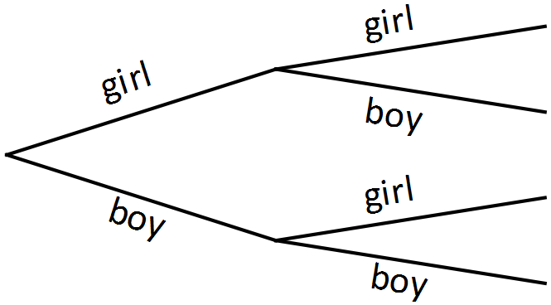
Specific behaviours | Marks | Rating
Correctly labels diagram for first child | 1 | simple
Correctly labels diagram for second child | 1 | simple
Total | /2

- What is the chance the family would have two girls?
Solution
first child second child
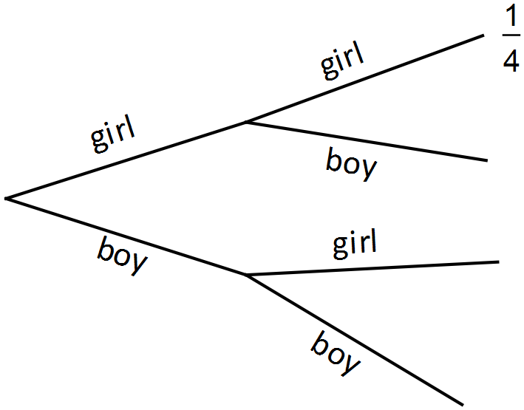 The probability of having two girls is

Specific behaviours | Marks | Rating
Recognises there are four possible outcomes | 1 | simple
Determines the probability of two girls | 1 | simple
Total | /2

- If the family had a third child, what is the chance there would be two girls and a boy?
Solution
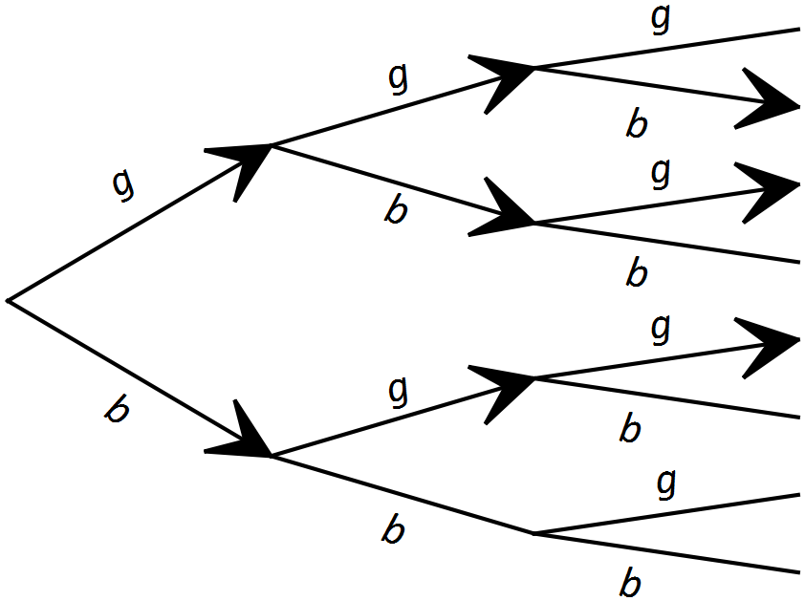
There are eight possible outcomes with three of these outcomes having two girls and a boy.
The probability would be or 0.375.
Specific behaviours | Marks | Rating
Extends sample space | 1 | simple
Recognises there are eight possible outcomes for three children | 1 | simple
Identifies three outcomes with two girls and a boy | 1 | complex
Determines the probability | 1 | simple
Total | /4

3. An agricultural research company has completed an investigation into the effect of a new fertiliser on plant growth. The heights of 50 plant seedlings grown under experimental conditions for several weeks were measured and recorded to the nearest centimetre.

107, 162, 151, 145, 133, 125, 116, 108, 111, 113, 125, 126, 158, 142, 139,
165, 168, 152, 141, 147, 147, 131, 137, 137, 111, 119, 121, 125, 125, 156,
117, 133, 138, 157, 124, 124, 159, 132, 131, 139, 141, 137, 129, 131, 148,
127, 136, 136, 121, 148
- Use the data to complete the table below:

Solution
Height (cm) | Frequency | Relative Frequency
 | 2 | 0.04
 | 6 | 0.12
 | 11 | 0.22
 | 14 | 0.28
 | 8 | 0.16
 | 6 | 0.12
 | 3 | 0.06

Specific behaviours | Marks | Rating
Correctly completes frequency column | 1 | simple
Correctly fills two rows of relative frequency | 1 | simple
Correctly completes relative frequency column | 1 | simple
Total | /3

- What is the probability of plants growing to a height between 120 cm and 129 cm?
Solution
Relative frequency for the height interval of is 0.22. So the probability is 0.22.
Specific behaviours | Marks | Rating
Identifies the relative frequency for the interval | 1 | simple
Recognises the relative frequency is an expression of probability | 1 | simple
Total | /2

- What is the probability of plants growing to a height of at least 130 cm?

Solution
32 plants have heights of at least 130 cm.
Probability is
Specific behaviours | Marks | Rating
Determines number of plants fulfilling criteria | 1 | complex
Determines probability | 1 | simple
Total | /2

- If the experiment is expanded to 1000 plants, how many plants would you expect to grow to a height of at least 130 cm?
Solution
Would expect 640 plants to grow to a height of at least 130 cm.
Specific behaviours | Marks | Rating
Applies relative frequency to calculation | 1 | simple
Determines the number of plants expected to meet criteria | 1 | simple
Total | /2

- The fertiliser is considered effective if 75% of seedlings have a height of 130 cm or more. Comment on the effectiveness of the fertiliser on plant growth based on the results from the experiment.
Solution
Relative frequency of 0.64 is the same as 64%
Of the 50 seedlings, only 64% reached a height of at least 130 cm , which suggests the fertiliser may not be effective.
Specific behaviours | Marks | Rating
Refers to relative frequency | 1 | complex
Connects relative frequency to percentage | 1 | complex
Draws a conclusion based on results | 1 | complex
Total | /3

- (a) Why are 200 numbers assigned to the letter E and only 100 numbers to the other letters?

Solution
There are twice as many E’s as any other letter in the word CEREAL
Specific behaviours | Marks | Rating
States the relationship of the number of E’s to the number of other letters | 1 | simple
Total | /1

The first 20 random numbers that Nguyen gets from his calculator are shown below, with his first number being 242, the second, 413, and so on.
242 | 413 | 176 | 075 | 500 | 832 | 416 | 974 | 587 | 004
723 | 124 | 543 | 219 | 853 | 361 | 643 | 054 | 387 | 634

(b) Use Nguyen’s random numbers to assign letters until you have spelt the word CEREAL.
Solution
Random number used | Letter
242 | E
413 | L
176 | C
075 | A
500 | R
416 | L
587 | R
004 | A
124 | C
543 | R
219 | E

Specific behaviours | Marks | Rating
Correctly completes the next entry in the table | 1 | simple
Correctly adds six entries to the table | 1 | simple
Correctly completes the table | 1 | simple
Total | /3

(c) How many packets of Wheat Flakes would Nguyen need to buy to win a prize in this competition, on the basis of the results in part (b)?
Solution
11
Specific behaviours | Marks | Rating
Correctly states the number of packs required | 1 | complex
Total | /1

- If you ran this simulation with your calculator, what would be the minimum number of times you would need to generate a random number to spell CEREAL?
Solution
6
Specific behaviours | Marks | Rating
Correctly states the minimum number of trials. | 1 | complex
Total | /1

- Nguyen’s friend Georgina buys 30 packets of Wheat Flakes. Will she definitely win a prize? Explain.
Solution
No, it is possible but not certain
Specific behaviours | Marks | Rating
Correctly states no with a supporting reason | 1 | complex
Total | /1

